**Git**

**Tutorial 1 (**[**https://www.youtube.com/watch?v=SWYqp7iY_Tc&list=PLepJyg1eWJjq1tfgH3lAi_0LHylgVZ9u4**](https://www.youtube.com/watch?v=SWYqp7iY_Tc&list=PLepJyg1eWJjq1tfgH3lAi_0LHylgVZ9u4) **)**

* 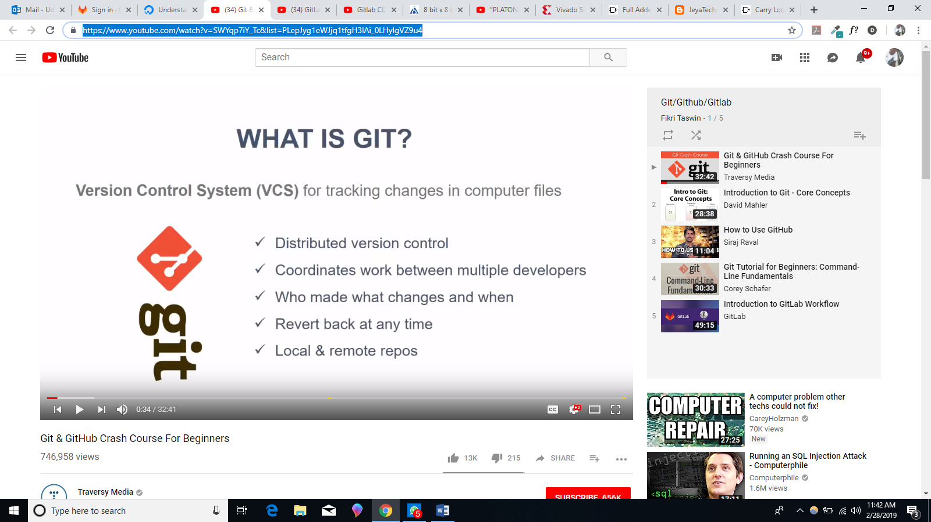
* 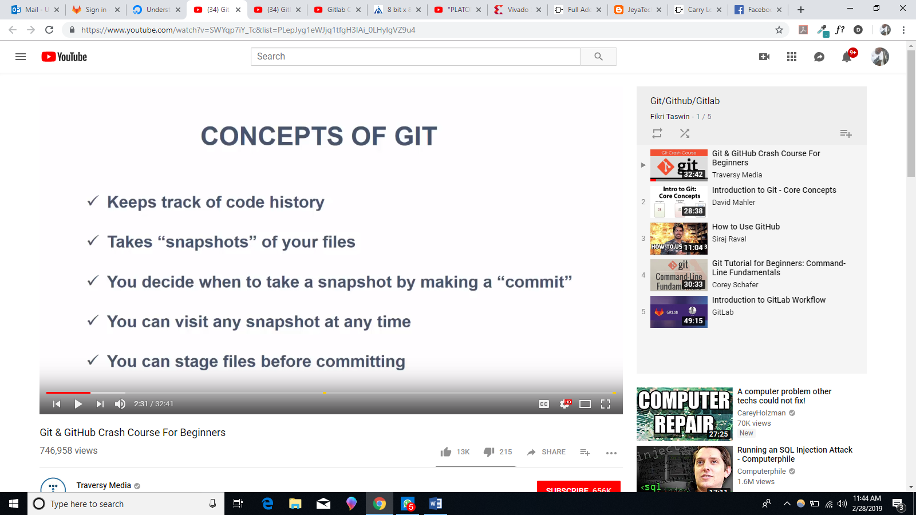
* 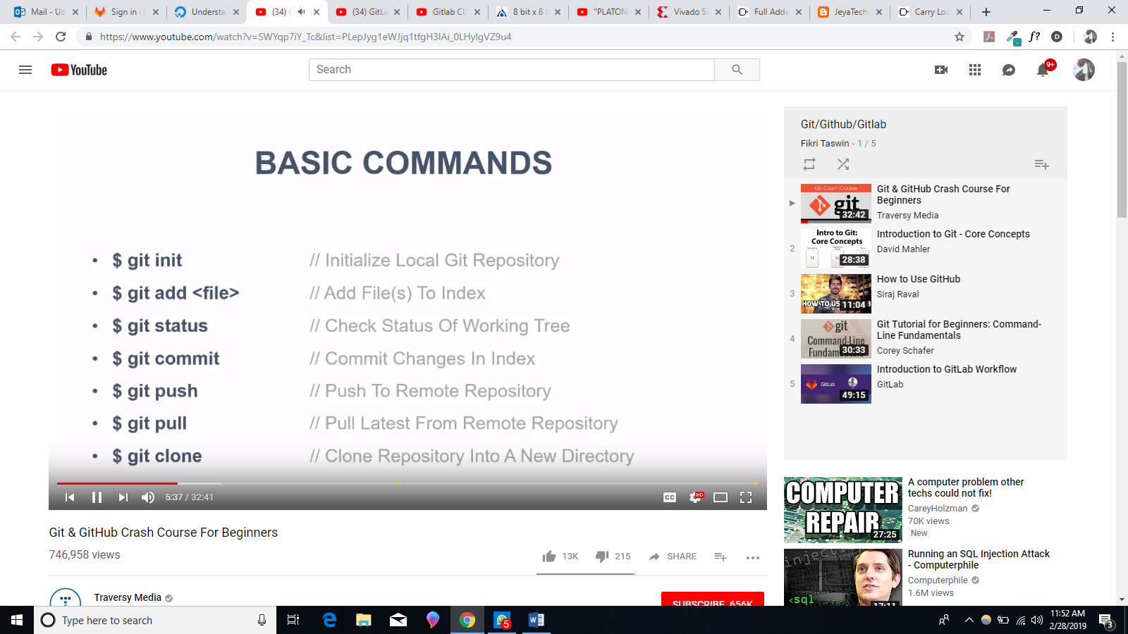
* 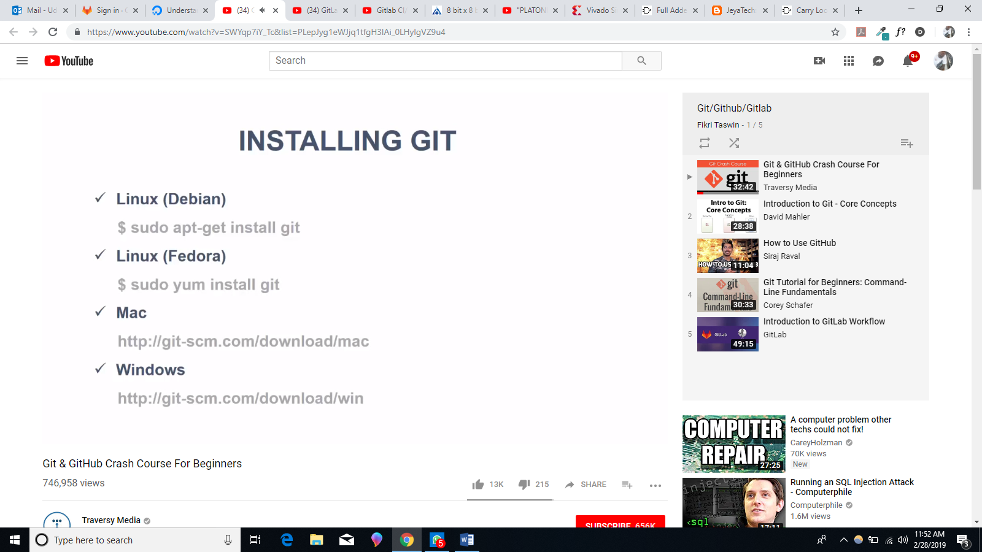
* 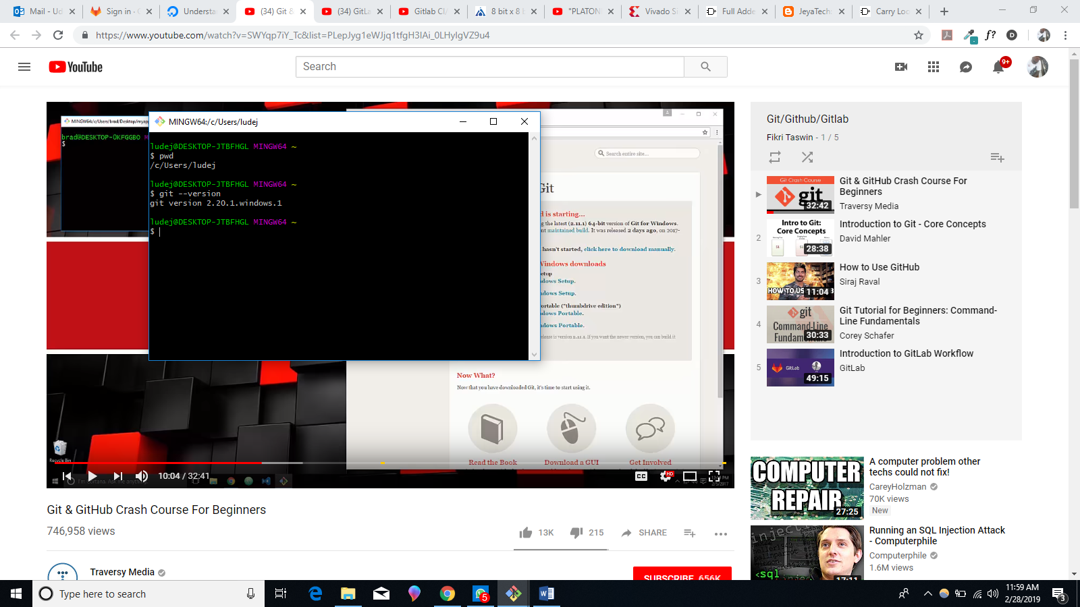
* 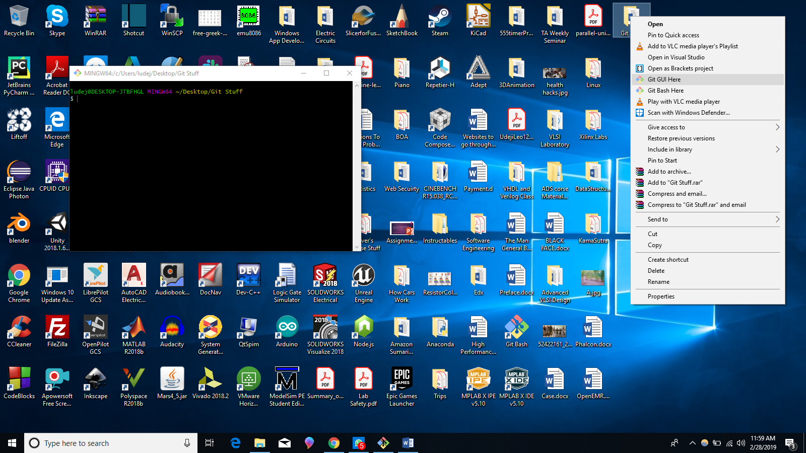
* By holding CTRL button and scrolling the mouse you can control the size of the git command line font. (I noticed that you can also use this to change your overall windows font size).
* 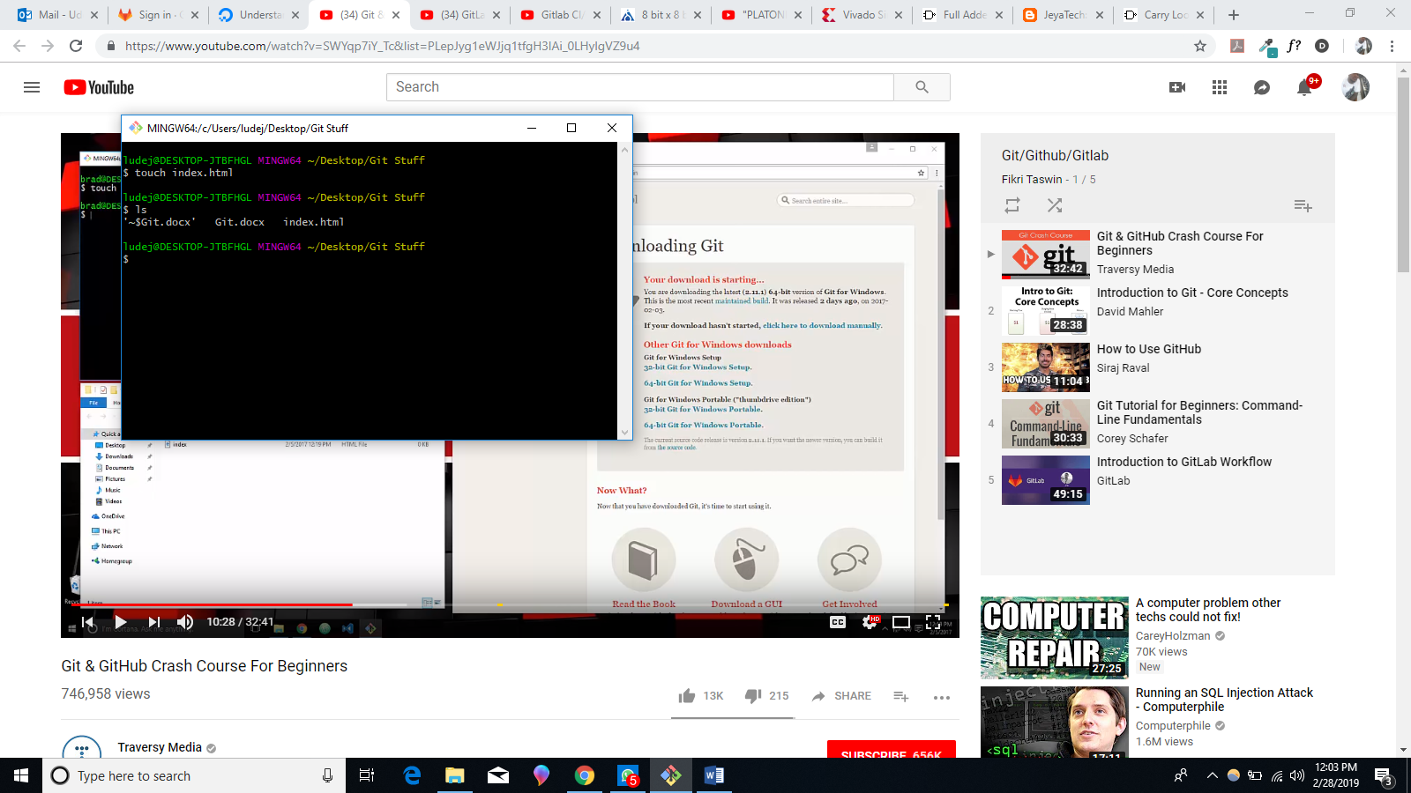
* 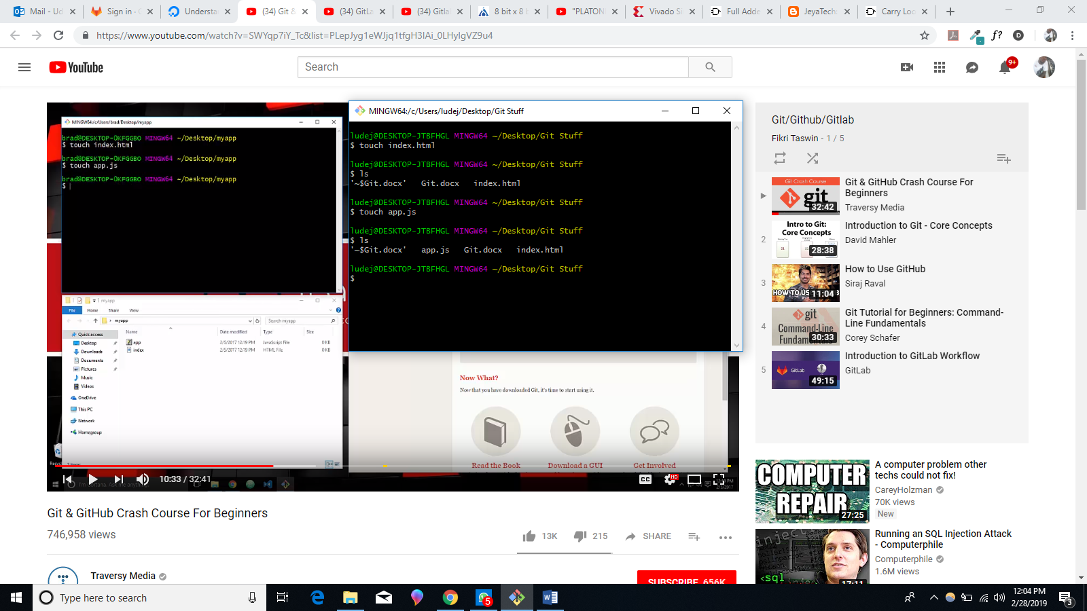
* We checked “hidden items” under View to make hidden items visible.
* 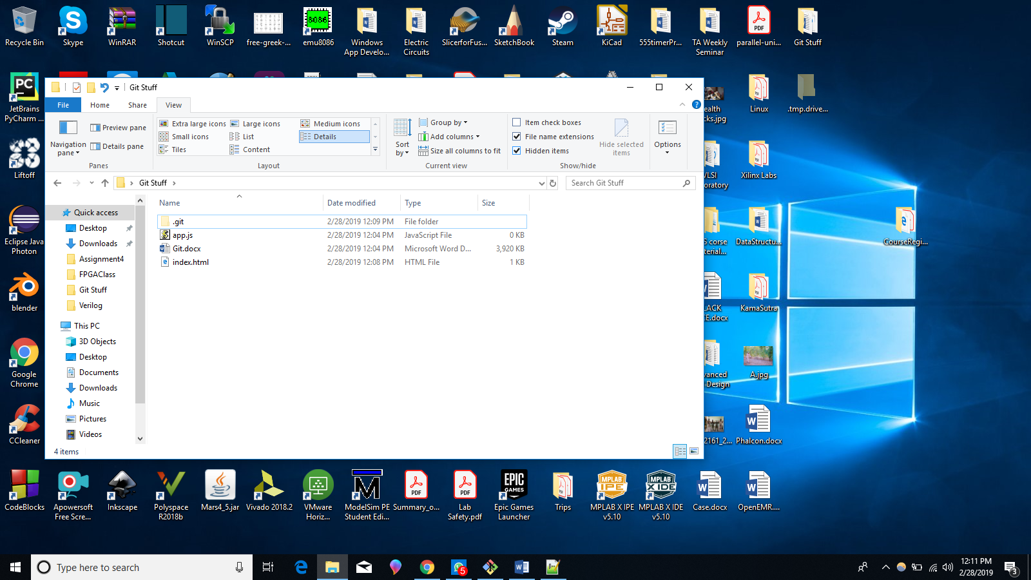
* 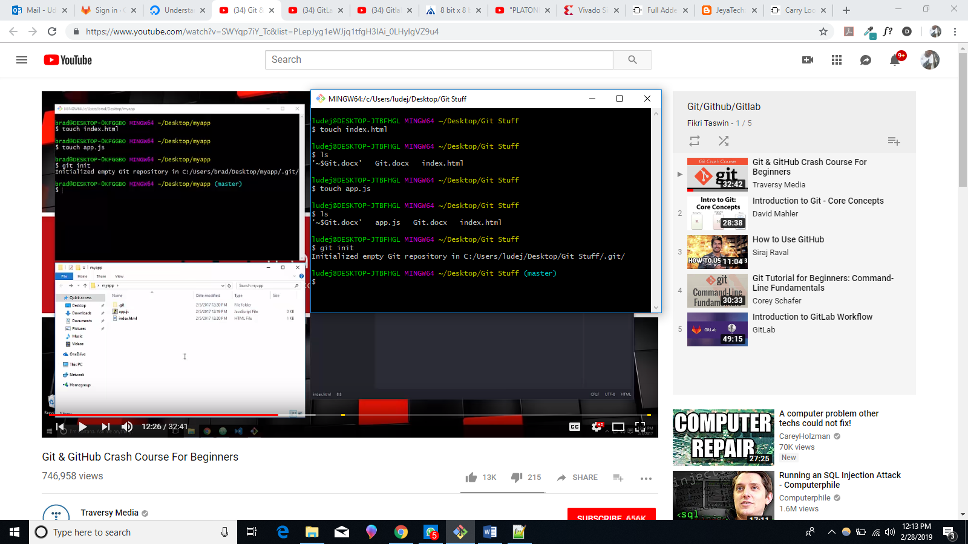
* Now that we have initialized this folder as a git repository we can start to use git commands.
* 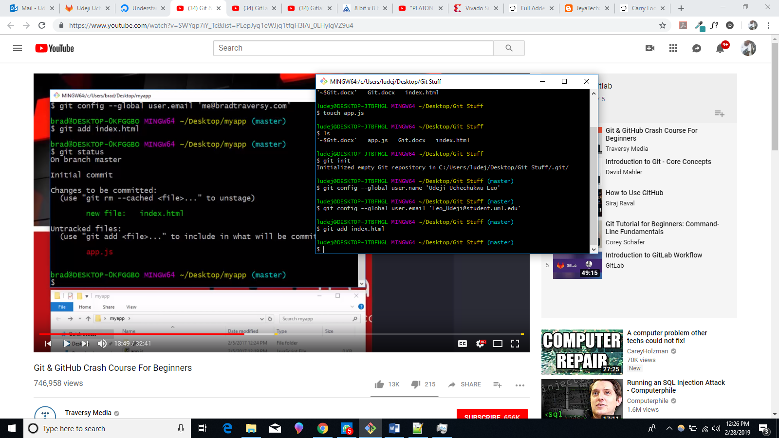
* 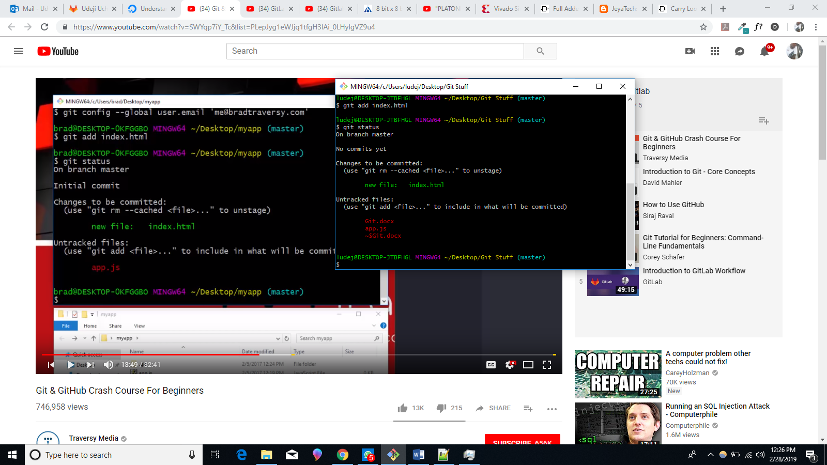
* 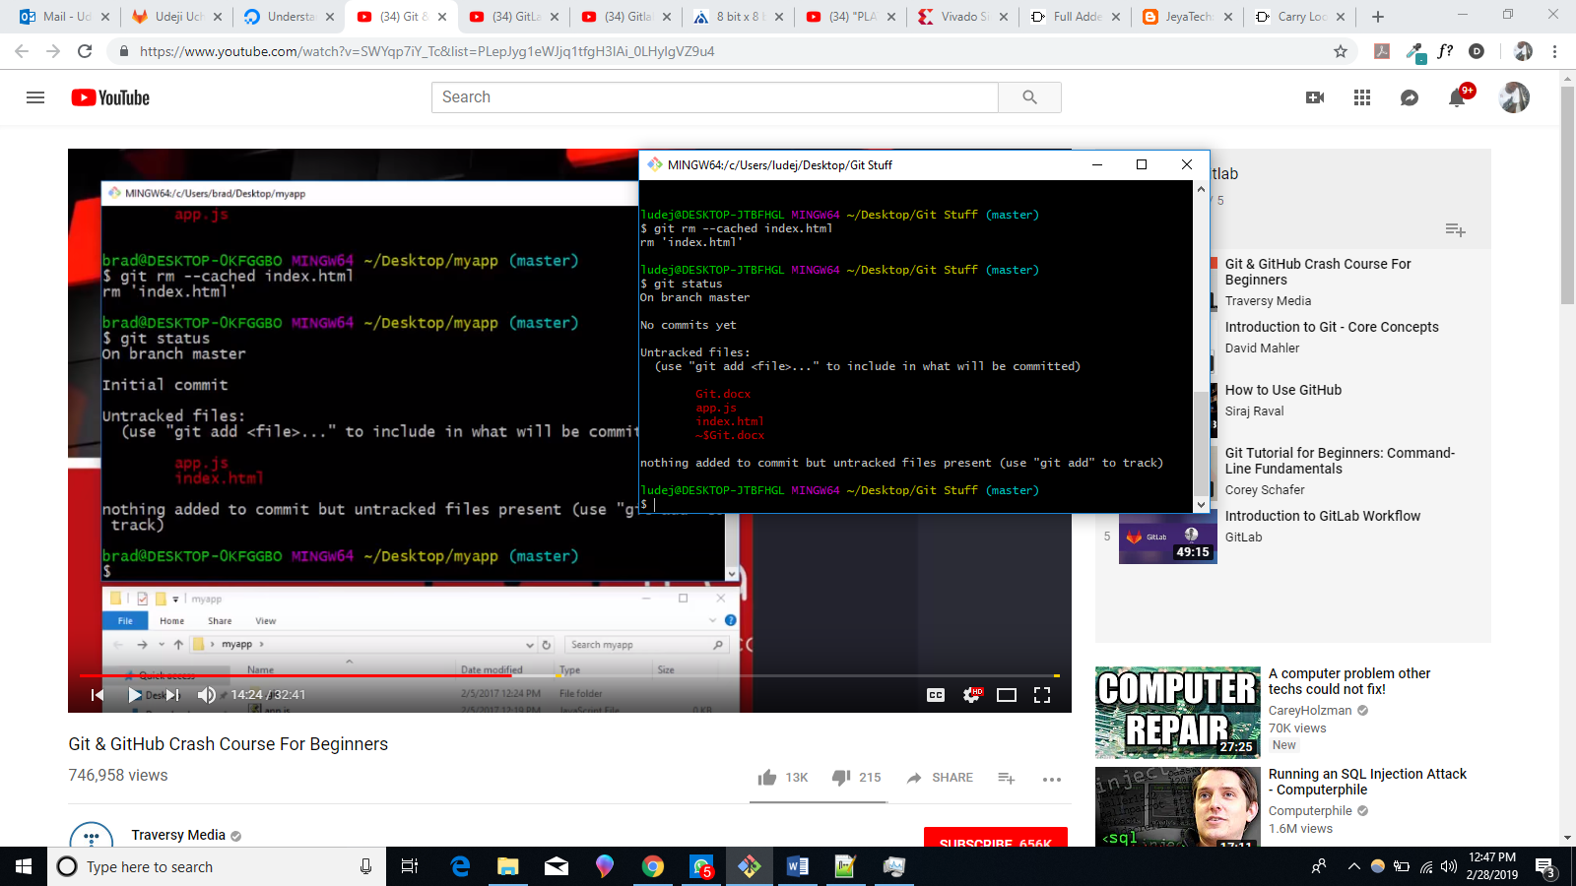
* **“git add *.html”** adds any html file to the staging area as shown below:
* 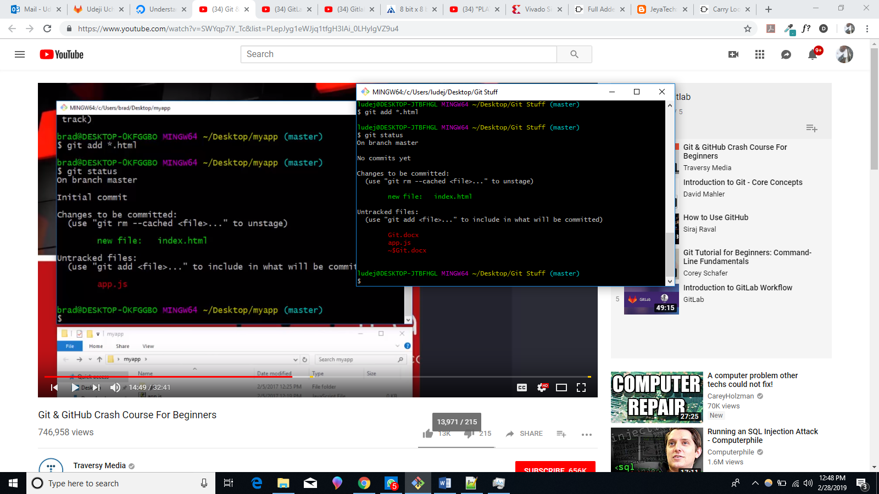
* **“git add . ”** basically adds everything in your folder.
* 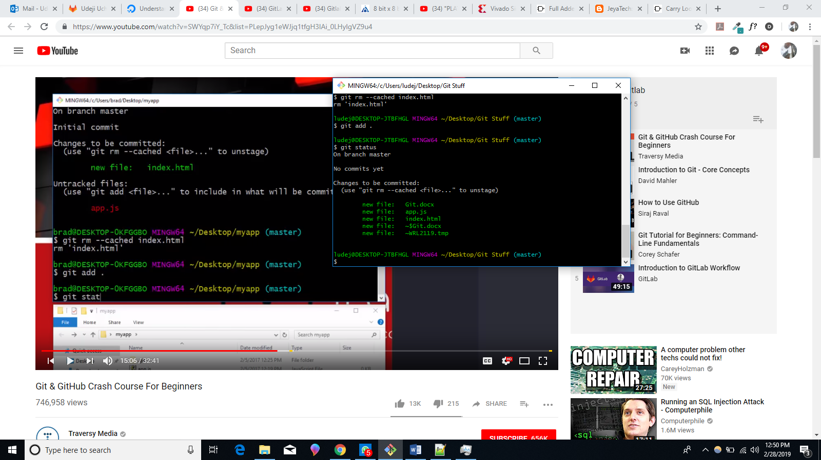
* If you edit any of the files and enter “git status” you will be notified of any changes that has been made.
* 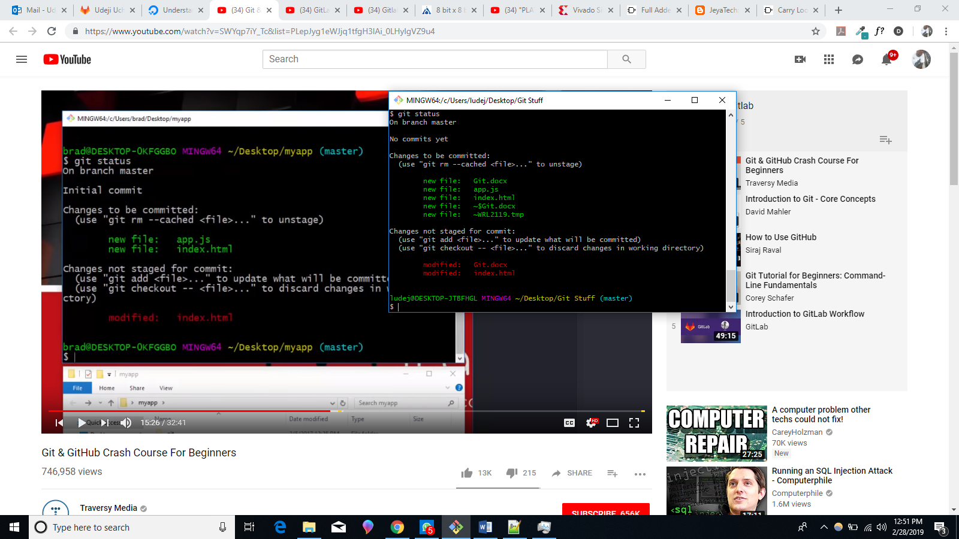
* **From the picture above** notice that “git checkout --” or “git add” command can be used to either discard or update the changes that has been made.
* 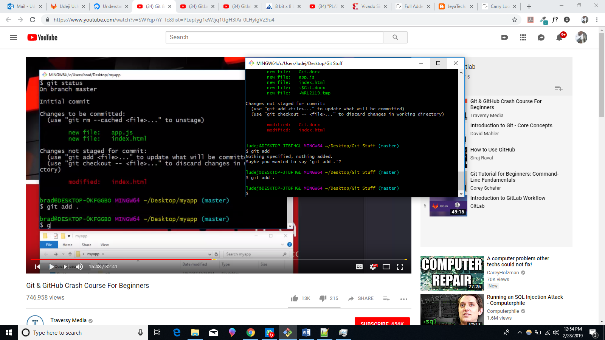
* 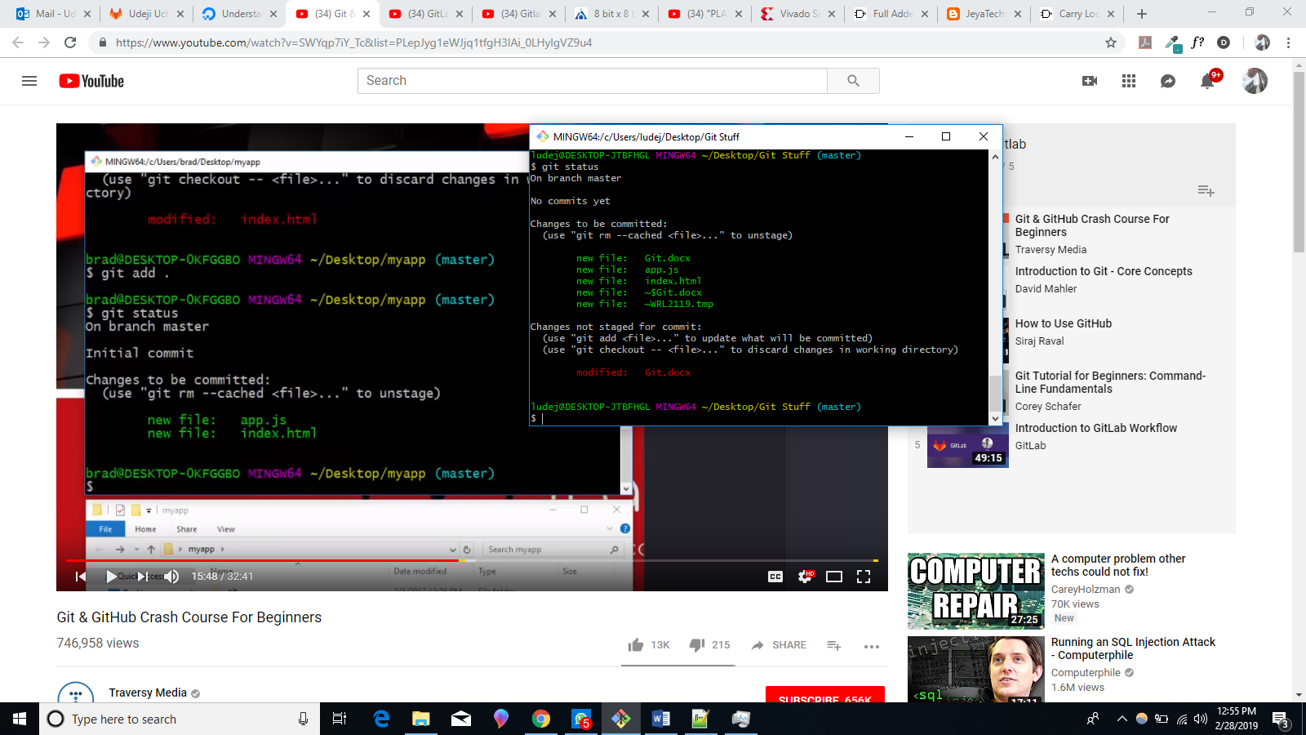
* **Press** ‘I’ to go into insert mode.
* 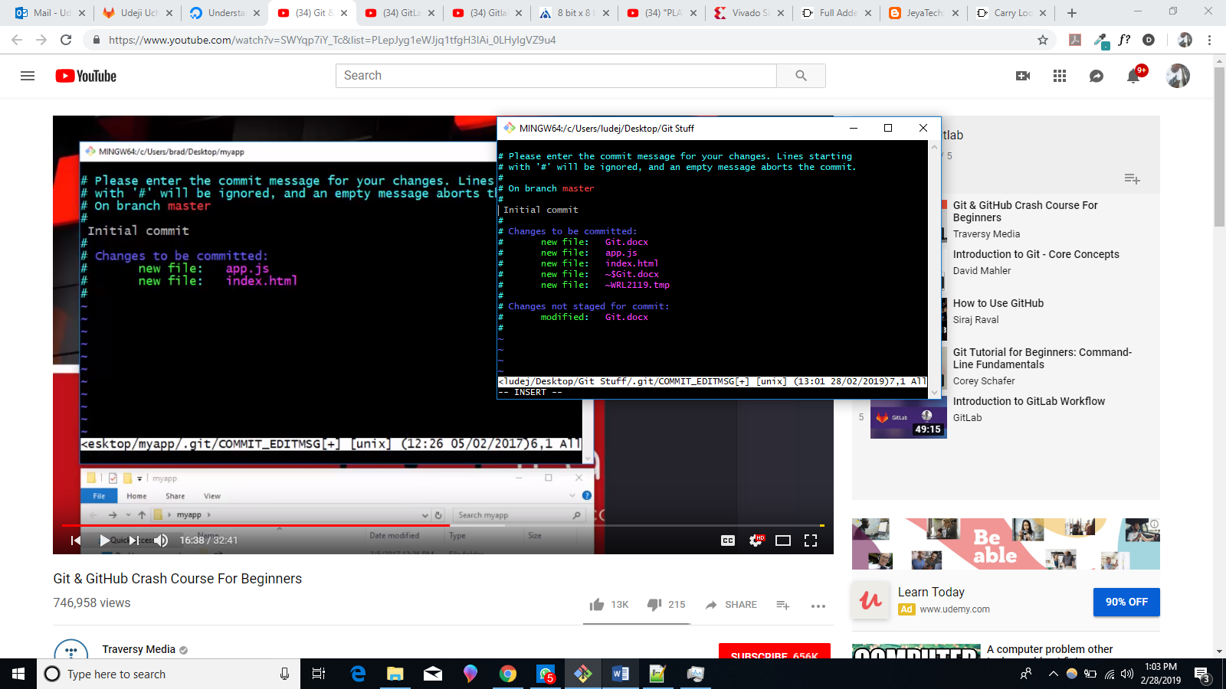
* **Then press escape.**
* **And type in** “:wq” This commits our files as shown in the picture below.
* 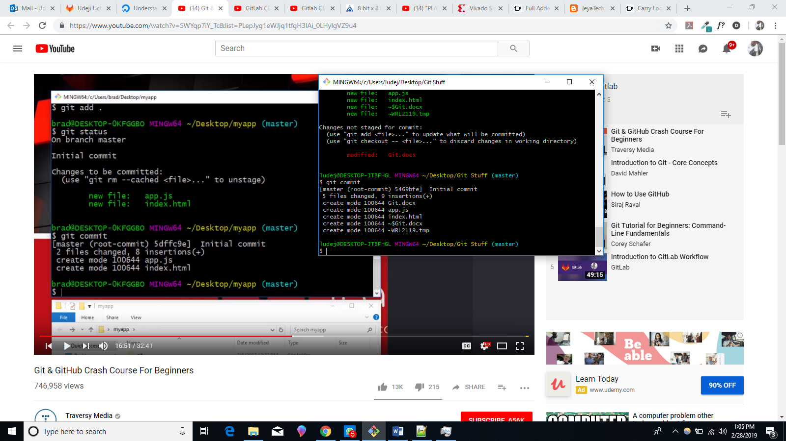
* 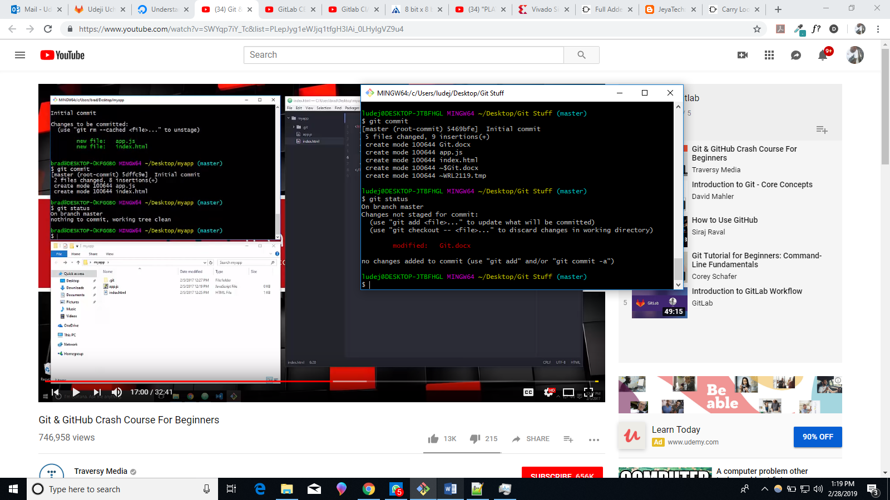
* **After I modified the app.js file we got the below:**
* 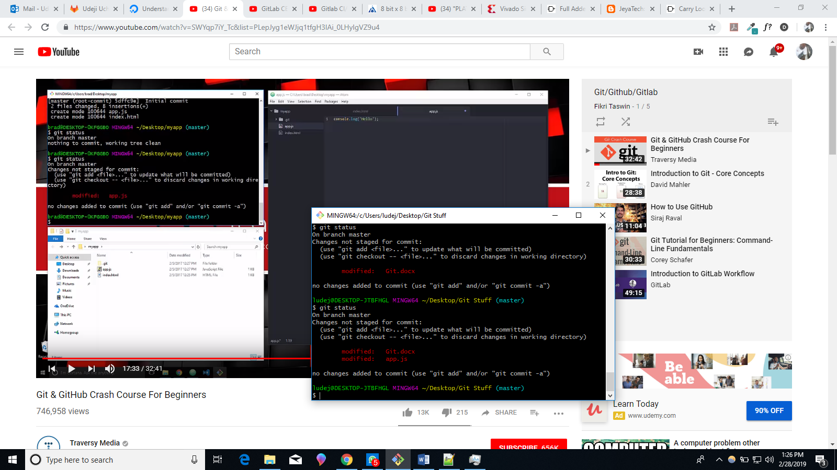
* 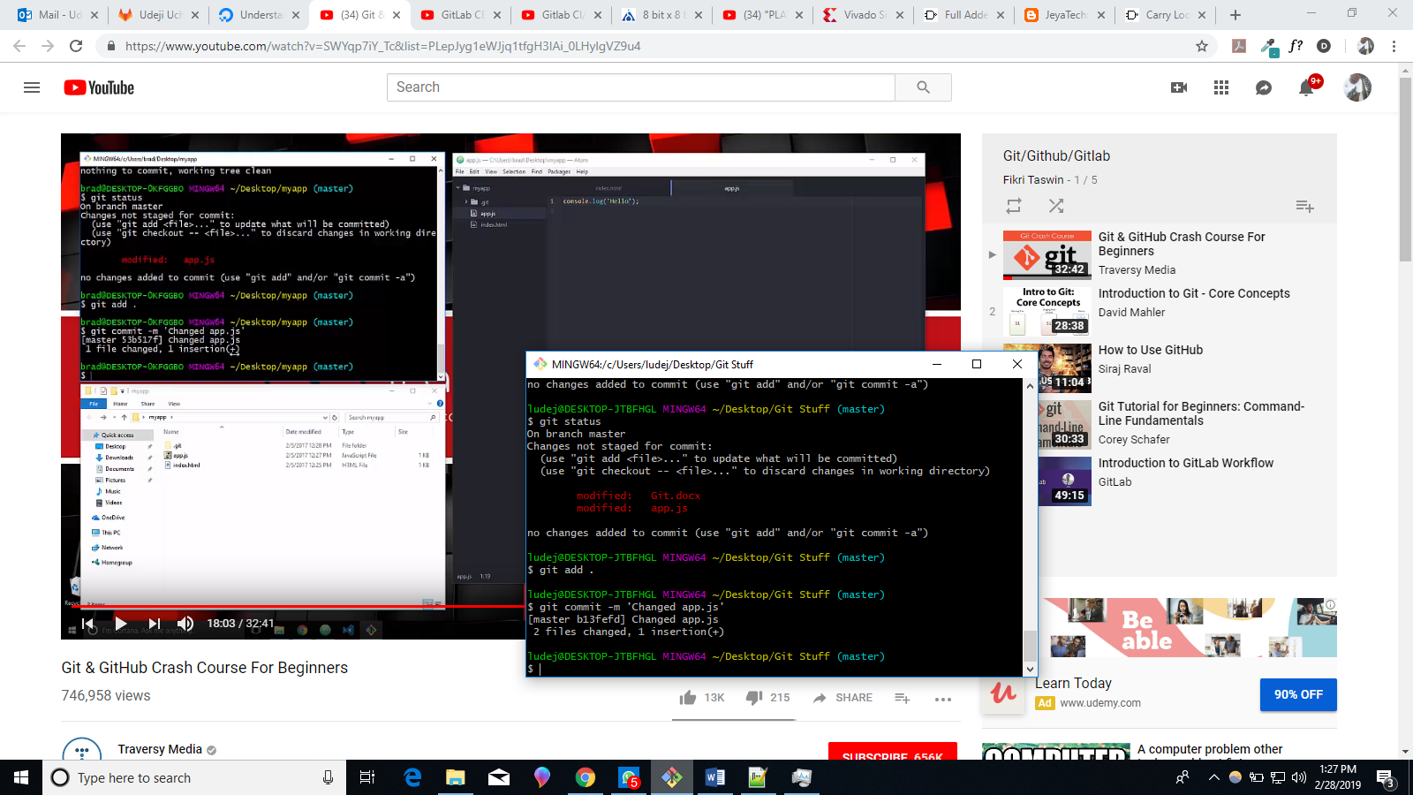
* **You won’t be able to create a** “.gitignore” file directly using windows file editor, because it will look at it as an empty name. Since extensions usually start with the ‘.’ Symbol.
* **Log.txt** is not included in the changes below because it’s been named in the “.gitignore” file
* 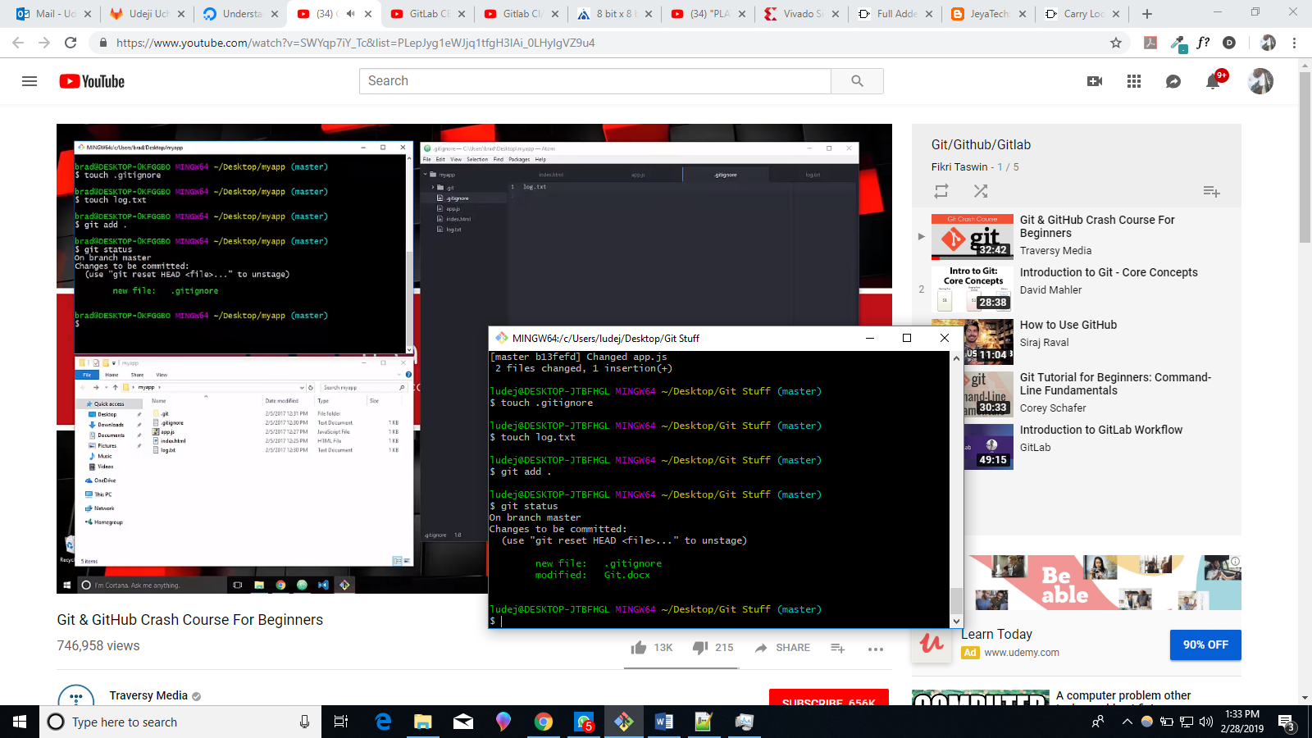
* **Before adding the whole folder to git ignore we had the below:**
* 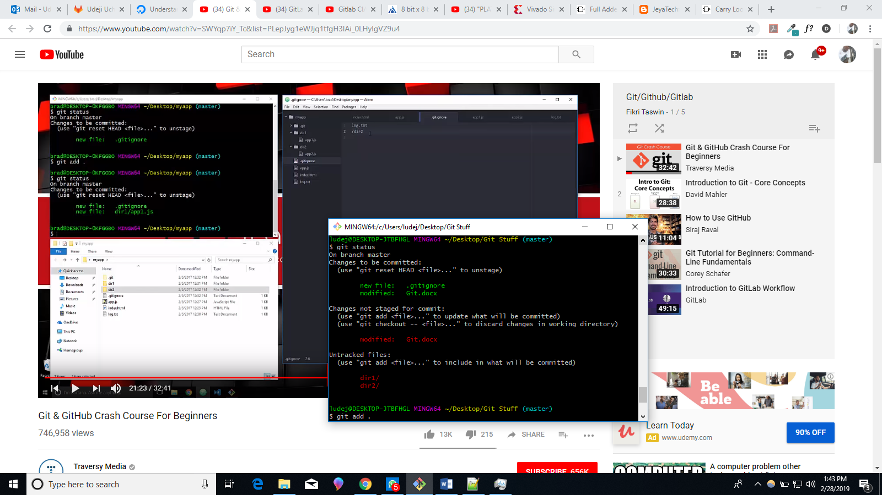
* **After adding the whole folder to git ignore we had the following:**
* 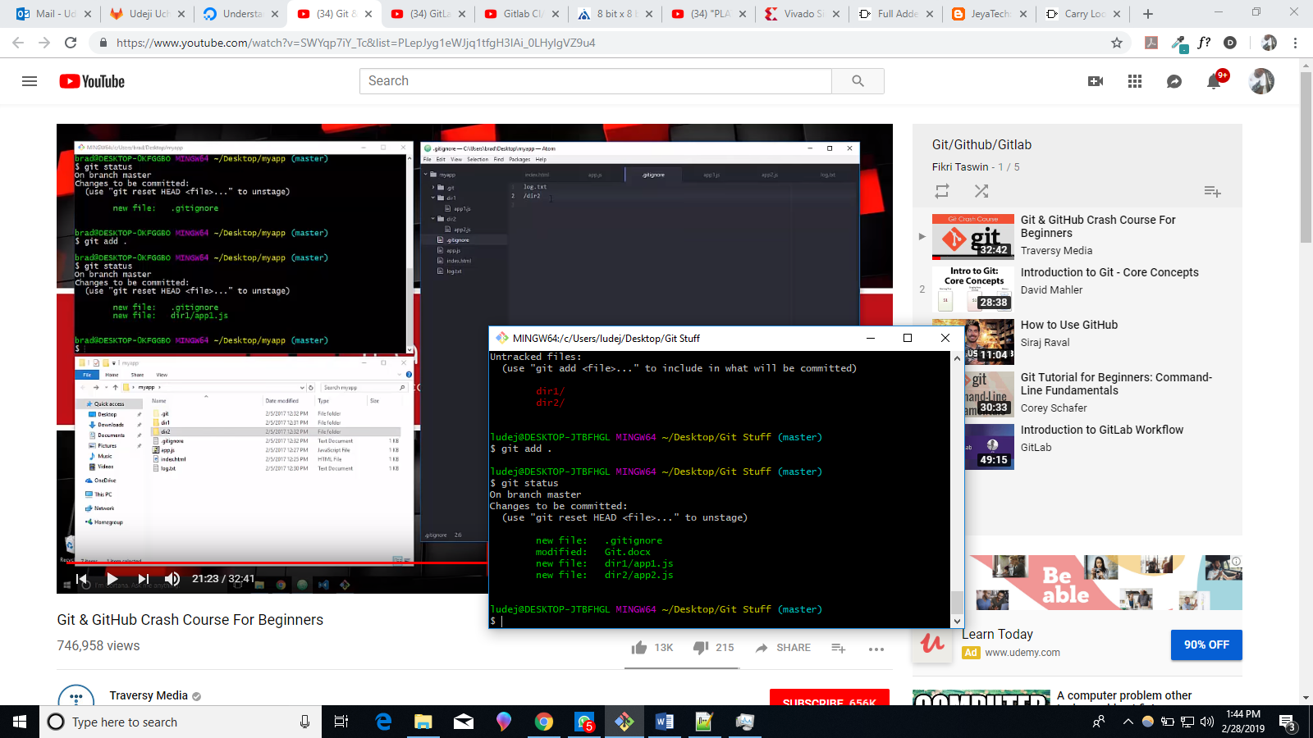
* Below we’re creating a new branch.
* 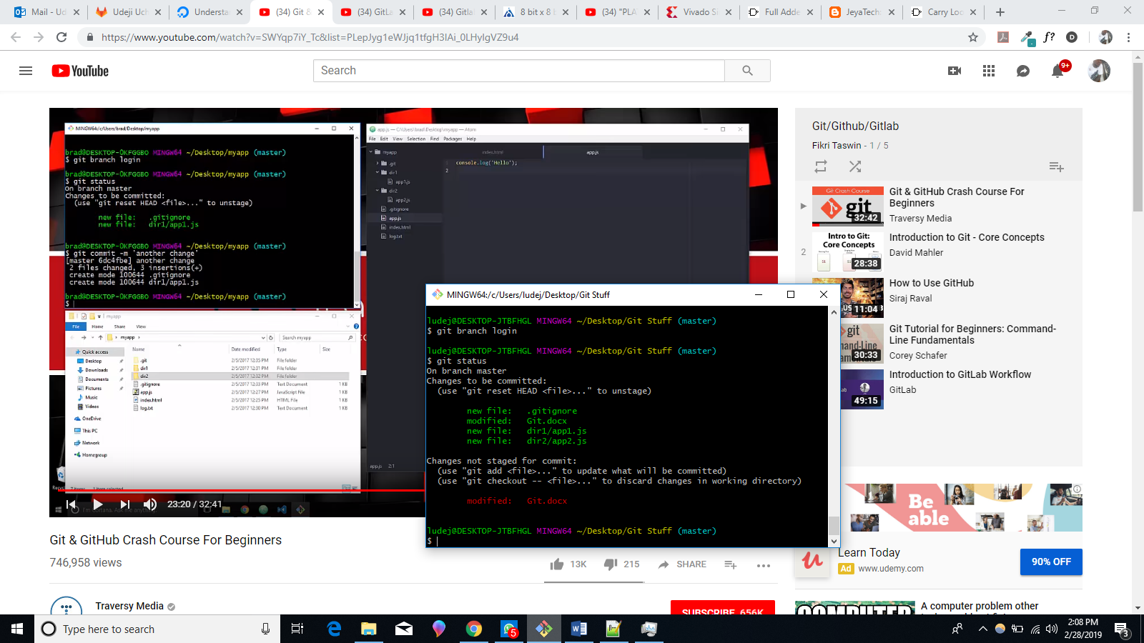
* 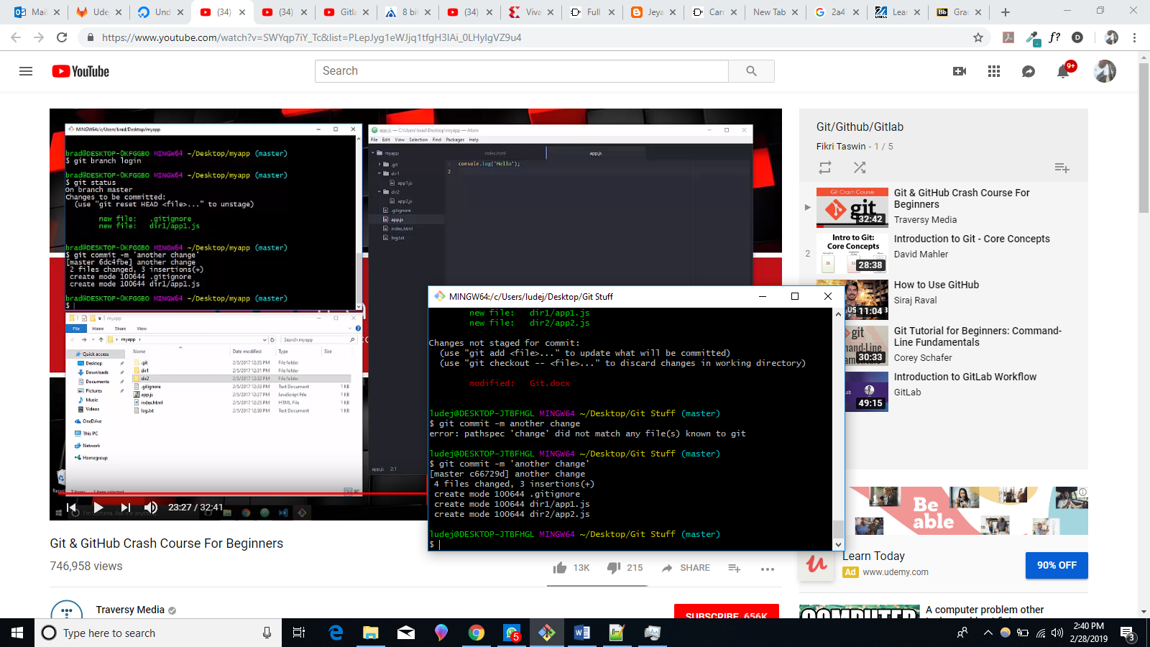
* **To** switch to our branch we use “git checkout nameofbranch”